Experiment No.2

Title:-Quick Sort, Mearge Sort using array as a data Structure.
Problem:- E-commerce: Sorting products by price, rating, or popularity.
Programm:-
#include <stdio.h>
#include <string.h>
typedef struct {
char name[50];
int price;
float rating;
int popularity;
} Product;
// ------------------ Swap ------------------
void swap(Product *a, Product *b) {
Product temp = *a;
*a = *b;
*b = temp;
}
// ------------------ Quick Sort ------------------
int compare_quick(Product a, Product b, char key[]) {
if (strcmp(key, "price") == 0)
return a.price - b.price;
else if (strcmp(key, "rating") == 0)
return (a.rating > b.rating) - (a.rating < b.rating); // returns 1,0,-1
else if (strcmp(key, "popularity") == 0)
return a.popularity - b.popularity;
return 0;
}
int partition(Product arr[], int low, int high, char key[]) {
Product pivot = arr[high];
int i = low - 1;
for (int j = low; j < high; j++) {
if (compare_quick(arr[j], pivot, key) < 0) {
i++;
swap(&arr[i], &arr[j]);
}
}
swap(&arr[i + 1], &arr[high]);
return i + 1;
}
void quickSort(Product arr[], int low, int high, char key[]) {
if (low < high) {
int pi = partition(arr, low, high, key);
quickSort(arr, low, pi - 1, key);
quickSort(arr, pi + 1, high, key);
}
}
// ------------------ Merge Sort ------------------
int compare_merge(Product a, Product b, char key[]) {
if (strcmp(key, "price") == 0)
return a.price < b.price;
else if (strcmp(key, "rating") == 0)
return a.rating < b.rating;
else if (strcmp(key, "popularity") == 0)
return a.popularity < b.popularity;
return 0;
}
void merge(Product arr[], int left, int mid, int right, char key[]) {
int n1 = mid - left + 1;
int n2 = right - mid;
Product L[n1], R[n2];
for (int i = 0; i < n1; i++) L[i] = arr[left + i];
for (int j = 0; j < n2; j++) R[j] = arr[mid + 1 + j];
int i = 0, j = 0, k = left;
while (i < n1 && j < n2) {
if (compare_merge(L[i], R[j], key)) {
arr[k++] = L[i++];
} else {
arr[k++] = R[j++];
}
}
while (i < n1) arr[k++] = L[i++];
while (j < n2) arr[k++] = R[j++];
}
void mergeSort(Product arr[], int left, int right, char key[]) {
if (left < right) {
int mid = left + (right - left) / 2;
mergeSort(arr, left, mid, key);
mergeSort(arr, mid + 1, right, key);
merge(arr, left, mid, right, key);
}
}
// ------------------ Print Products ------------------
void printProducts(Product arr[], int n, char key[]) {
printf("\nSorted by %s:\n", key);
for (int i = 0; i < n; i++) {
printf("%s - $%d - %.1f stars - %d popularity\n",
arr[i].name, arr[i].price, arr[i].rating, arr[i].popularity);
}
}
// ------------------ Main Function ------------------
int main() {
Product products[] = {
{"Laptop", 900, 4.5, 150},
{"Headphones", 150, 4.7, 300},
{"Keyboard", 70, 4.3, 120},
{"Monitor", 300, 4.6, 200},
{"Mouse", 50, 4.4, 250}
};
int n = sizeof(products) / sizeof(products[0]);

char key[20];
int choice;

printf("Enter sorting attribute (price, rating, popularity): ");
scanf("%s", key);

printf("Choose algorithm: 1. Quick Sort 2. Merge Sort\n");
scanf("%d", &choice);
if (choice == 1)
quickSort(products, 0, n - 1, key);
else
mergeSort(products, 0, n - 1, key);
printProducts(products, n, key);
return 0;
}
Output:- 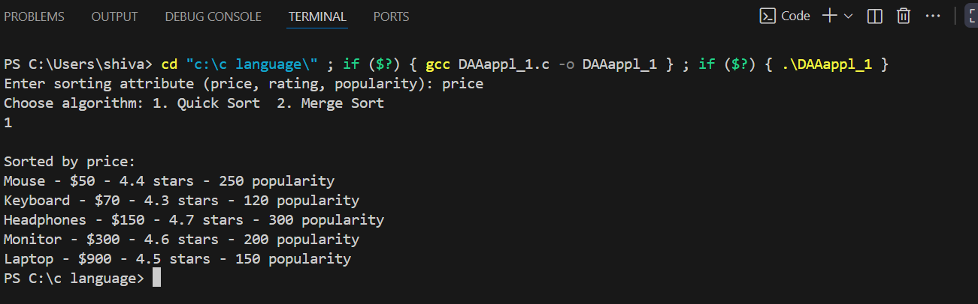

Quick Sort Applications
- E-commerce Product Sorting
  - Sorting products by price, rating, or popularity to display to customers efficiently.
- Database Query Optimization
  - Sorting query results before applying further operations like grouping or filtering.
- Computer Graphics
  - Sorting elements like z-values of objects for rendering (painter’s algorithm) efficiently.
- Networking
  - Sorting packets or requests by priority or timestamp before processing.
- Game Development
  - Sorting scores, leaderboard entries, or in-game items dynamically.

Merge Sort Applications
- External Sorting
  - Sorting large datasets that don’t fit into memory (e.g., log files, transactions) using arrays/chunks.
- Stable Sorting Requirements
  - When maintaining the original relative order is important (e.g., sorting a list of employees by salary while preserving order by name).
- Linked List and Array Sorting in Software
  - Sorting arrays in scientific computations or sensor data where stability matters.
- Data Compression
  - Sorting frequencies for Huffman coding in compression algorithms.
- File Merging
  - Efficiently merging sorted data arrays or streams in applications like search engines, databases, or log aggregation.

